

West Georgia Society for Human Resource Management
presents…

Mark Butler
Georgia Department of Labor Commissioner

Thursday, August 9, 2012
11:45 A.M. — 1:00 P.M.
West Georgia Technical College, West Campus
Orchard Hill Rd, LaGrange, GA
(City of LaGrange Room)

Members of West GA SHRM: included in your dues
Nonmembers: $ 15.00
Program Includes Lunch and 1 HRCI Credit
There will be a fundraiser for the SHRM Foundation

Seating is limited, register before August 3, 2012

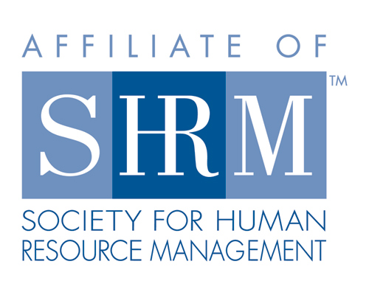
www.westgashrm.org

